**Part1 ：学院信息系统**

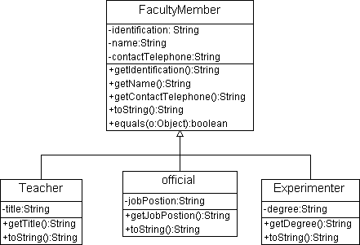

**Part2 ：顾客系统两种设计方案讨论**

面向对象系统中功能复用的两种最常用技术是类继承和类与类之间的关联。

类继承的优势：

（1）在编程语言中子类使用语法关键字可轻易复用父类的功能，举例：extends(java)；（2）系统可以任意扩展新的子类，代价较小，举例：除了individual customer和institutional customer，再增加商业顾客

缺点：子类依赖于超类特定功能的实现细节。超类发生变化，即使子类的代码完全没有改变，子类也可能会被打破，一些功能无法正常实现；打破了基类封装，因为基类向子类暴露了实现细节。

关联的优势：（1）因为通过接口访问对象，所以并不破坏封装性；（2） 类操作是基于被包含类的公开操作接口而写的，所以实现上存在较少的依赖关系。（3） 每个类专注于一个任务。

除非用到向上转型（举例两种customer system的实现方案），否则优先使用对象组合，而不是类继承。

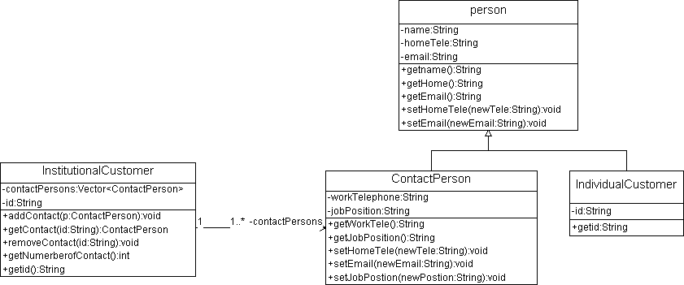

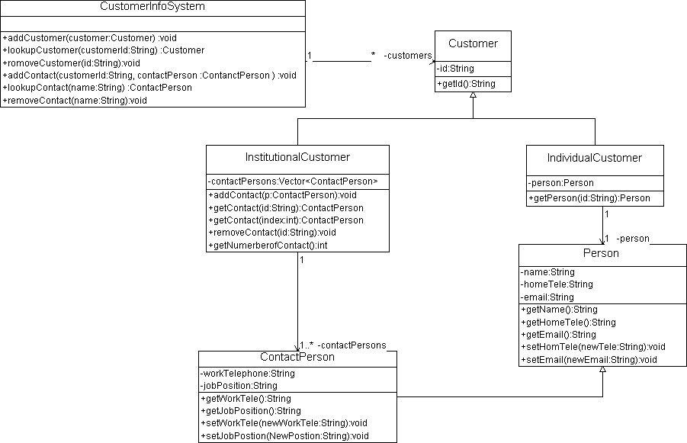

## Customer Information System

The customer information system maintains information about two different kinds of customers:

* Individual customers: For these customers, the system stores an ID and the information about a person (name, home telephone number, and email).
* Institutional customers: For these customers, the system stores an ID and provides the capability of defining one or more contact people for the institution. The system stores the following information for each contact person: name, home telephone number, email, work telephone number, and the job position of the contact in the institution.

Assume that each customer has a unique ID and that IDs cannot be modified. Assume each contact for an institution has a unique name.

The system provides the following functions:

* Add a customer into the system
* Look up a customer given an ID
* Remove a customer from the system given an ID
* Add a new contact for an institutional customer
* Look up a contact given the ID of the institution and the name of the contact
* Remove a contact given the ID of the institution and the name of the contact